Loan Fairness Tasks

1. Data cleaning. Any missing values. Any illegal values.

2. Scale nonbinary features and make a boxplot collection as below. Make bar charts for counts for binary features. Make other nice pictures related to the dataset. Like pie chart of yes/no loan decisions. Many other inspirations at https://www.kaggle.com/code/sumit12100012/loan-approval-eda-multiple-models.
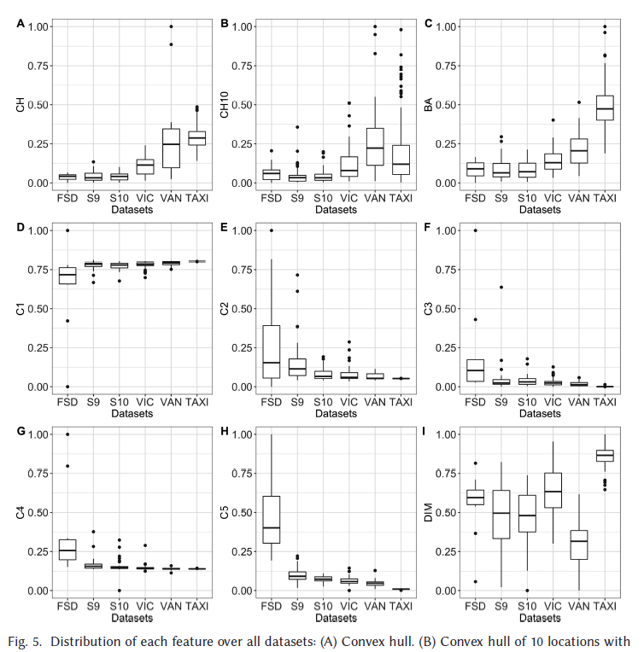

3. Feature importance will be a useful piece. At Kaggle they plot the feature importance for the best XGBoost model. “Previous loan defaults on file” is overwhelmingly important to the decision. We should be looking at this for any kind of model we investigate. I propose that if we are really going to address loan fairness, we should see how all our models do without the “previous loan defaults on file” feature. Also, it will be useful to use this more challenging feature set because it will presumably lead to lower accuracies, which will help us distinguish our approaches, especially quantum approaches.

4. Read details for specific possible quantum algorithms. Assessing which of them can be applicable/implemented for our loan dataset.

5. Select variety of models that can be applied to this dataset and implement them. Including tuning hyperparameters, k-fold, etc. Look at feature importance and try the same without “previous loan defaults on file.”

6. Once quantum algorithms are running, let them feed classical classifiers.

